Innovation Journal

Innovation Idea - Complete the Following:
Find a product or process that needs innovation (a dynamic new idea).
Research the company that currently owns the process or product.

Observe people that use the product or process.
Scrutinize the product or process.
Observe the product or process in use.
Research the creator of the product or process.
Research the changes that the product or process has gone through.
Determine why the product needs to change.

Notes about the product/ process, the company, the changes

Describe the Product or Process (currently)

Describe the company that owns the product/ process. Why is innovation a positive move for the company?

Describe why the product or process needs to change. What is the expected effect of innovating the product or process?

INnovation Journal

Exploring passion and purpose in Innovation- COmplete the Following:
Think of a time when you were creative.

Find a creative person and observe him/her.
Do something creative.
Think about how creativity and innovation go together.
Think about what you are passionate about.
Research passionate companies.
Research innovation. Research how it is managed.
Compare those companies to the company you have chosen to innovate.
Watch the Deep Dive Series.

Notes about creativity

Describe a time in your past when you were creative. How did it feel? What did you do?

Describe what you are passionate about? Can this be a part of your career and life?

Describe a company that is passionate about innovation. How did the company become innovative? What characteristics does the company possess? How does it project this passion?

Define innovation. How does it work? Who can be innovative?

Passionately tell the story of why the product or process you have chosen needs innovation.

INnovation Journal

Innovation Styles and strategies: Complete the following
Complete the interactive module to learn more.

Find 5 products/ processes that are known for disruptive innovation.
Find 5 products/ processes that use lean innovation.
Research when open innovation is utilized.
Determine when to use Jugaad vs. systematic innovation.
Compare companies that use the different innovation styles and strategies.
Determine what you will need to effectively innovate the product/ process.

Notes about innovation styles and strategies

Describe the innovation styles/ strategies and when each should be used. Is one style (or strategy) better than another for a given situation?

Describe how 5 companies have used the different innovation strategies. What was the effect of the strategy? What was the product/ process? Was there a First Mover Advantage?

Create a Diagram that clearly and accurately shows what innovative strategy each company has employed, the effect, and the product innovated.

INnovation Journal

Create and Innovate the product or process
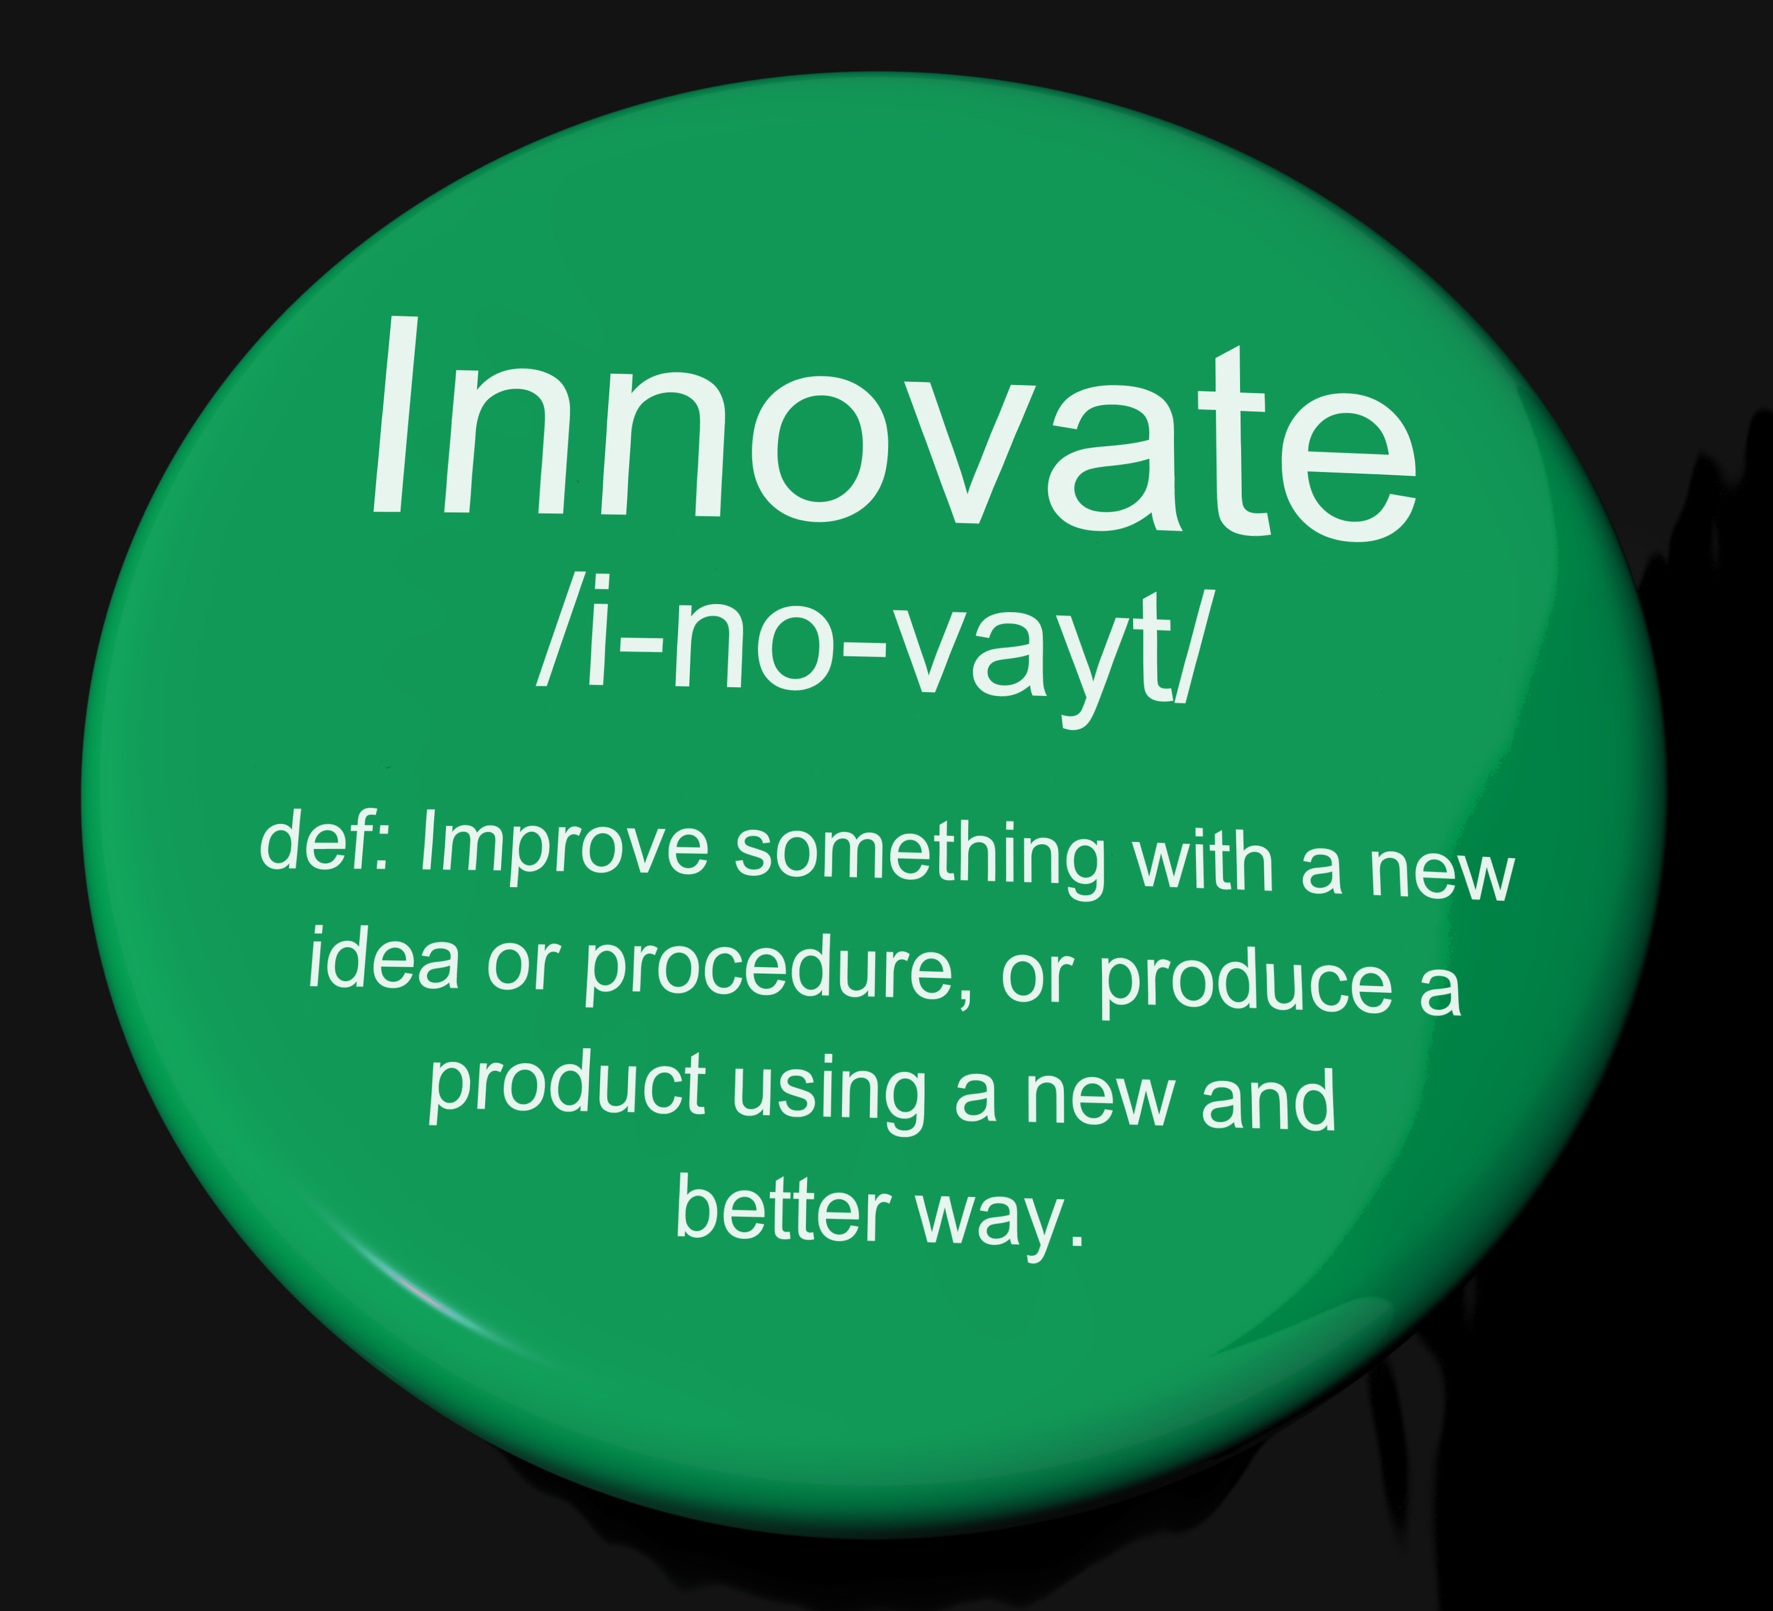
Begin to plan how you will innovate the product or process.
Obtain a detailed description of the product or process.
Use Gogamestorm.com to brainstorm how to innovate your product/ process.
Tinker with the product or process.
Determine what you will need to effectively innovate the product/ process.
Determine what unique characteristics your innovated product or process must have.
Try to innovate the product or process using Jugaad, disruptive, open, systematic, or lean innovation.

Notes about the innovation process

Describe what you hope the innovated product will do, look like, and accomplish.

Begin to innovate. Describe your thoughts and research behind your innovative idea(s) for the product or process. Use a gogamestorm.com activity to brainstorm.

Passionately tell the story of what the product or process will achieve if the company innovates.

INnovation Journal

Leadership in innovation

Analyze leadership styles in innovative corporations such as Virgin Atlantic, Google, and Lego
Research Lego Innovation Management
Research how to choose which idea the best leaders choose to innovate.
Research Crowdsourcing.
Analyze the benefits and detriments of crowdsourcing.
Determine whether crowdsourcing will work with your innovative product or process.
Determine what type of leader you will need to innovate your product or process.

Notes about innovative leaders

Describe crowdsourcing. Will it work to innovate your product or process?

Describe leadership styles in innovative. What do the best innovative leaders look like?

Create an infographic of the ideal innovation leader for your product.

INnovation Journal

You as a Leader in innovation

Look deeper into how you can lead innovation for the product or process.
Identify leadership characteristics you can incorporate into your leadership style.
Develop a plan to foster innovation amongst your team.
Search for activities to kick off an innovation project.
Develop a list of characteristics you will need in the innovation team members.
Decide whether the current company model will allow you to lead an innovation team.
Develop a plan of how to convince leadership to allow you to lead this team.

Notes about innovative leadership

Passionately describe (in a scripted storytelling format) your leadership style and how you are poised to lead an innovation team.

Methodically describe how you will lead the innovation team. Do you need team building exercises, innovation activities, creativity training, or other hands- on idea generation activities?

Write a script (for the final project), clearly and passionately displaying leadership potential for pulling together a team that is eager to see the product completed successfully.

Innovation Journal

CorporATE CULTURE & ECOSYSTEM - Complete the Following:
Investigate the corporate culture at several innovative companies.
Research common ecosystem characteristics of innovative companies.
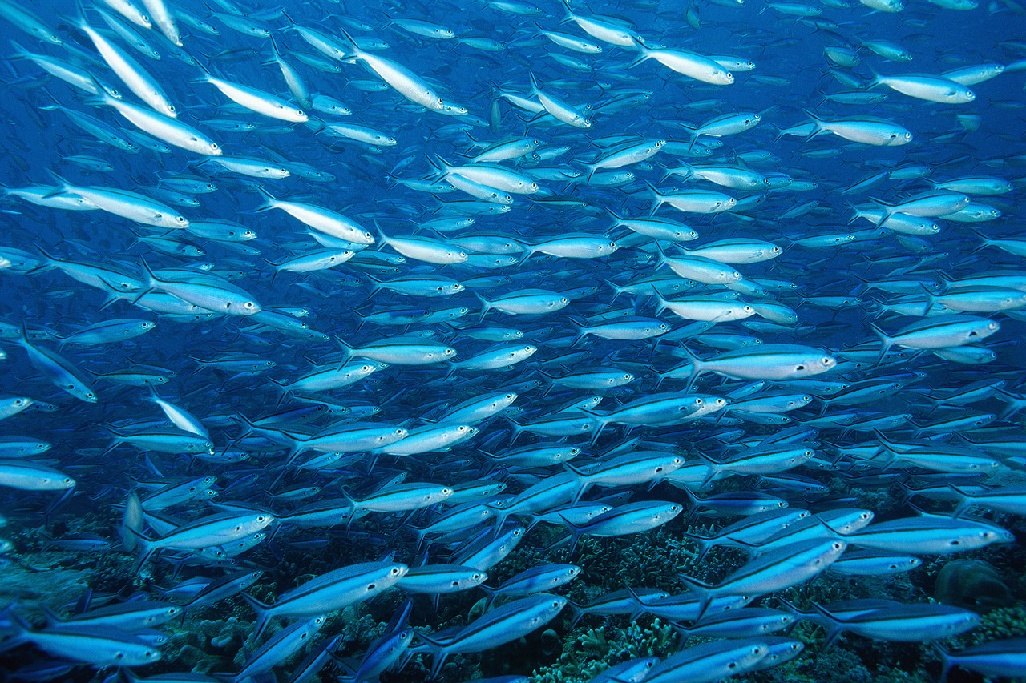
Observe people that work in this environment.
Scrutinize the products or processes these companies make.
Investigate common pitfalls within the ecosystem that could threaten innovation.
Research the ecosystem of the company you have chosen.
Determine whether this ecosystem can innovate.
Identify ecosystem and corporate culture issues that need to change to accommodate innovation.

Notes about corporate culture and ecosystems of innovation

Describe the characteristics of an innovative ecosystem.

Describe corporate culture and ecosystem of the company you have chosen?

Passionately describe how the new product (or process) you wish to innovate fits within this corporate culture? Suggest ways that the company can embrace innovation and your new idea.

INnovation Journal

The innovation pitch and executive summary- COmplete the Following:
Review the innovation idea in light of your product or process (Journal Entry 1)

Review your passion and purpose in light of your product or process (Journal Entry 2)
Review Innovation styles and strategies in light of your product or process. (Journal Entry 3)
Review your innovation (Journal Entry 4).
Review leading innovation (Journal Entries 5&6).
Review the corporate culture and ecosystem of innovation (Journal Entry 7).
Create (script and perform) an innovation pitch.
Draft an executive summary for your innovation.
Present the innovation pitch.

Notes about innovation Pitch and Executive Summary

Look and rubric and project directions. Create an outline for your project.

Draft your script for the innovation pitch.

Draft your executive summary.

